Why should I complete the FAFSA?
- This application determines your eligibility for a Federal Pell Grant. The Pell Grant is need based (based on income) and can be as much as $6195 per year. The amount you receive depends on your income.
- State scholarships such as TNPromise and Hope Scholarship require that you file a FAFSA.
- Many schools use FAFSA information to help award their school scholarships.
How do I apply?
- Go to the official site at FAFSA.ED.GOV
- Only use the official site. There are other sites where you can complete this process and you will be charged when you try to submit. Remember: FAFSA is a free application. You should never pay to file the FAFSA.

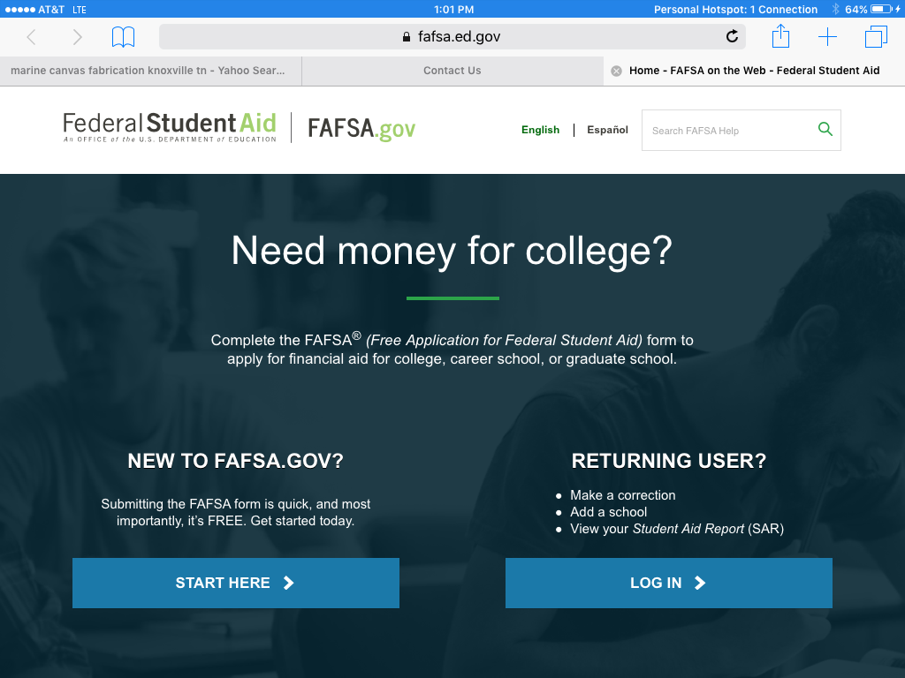
1
The first thing you need is an FSA ID.
- This is simply a username and password.
- You will need one and one of your parents (if you are a dependent student) will need one.
- If you have older siblings that are in college, or your parent is a college student, that parent probably already has an FSAID.

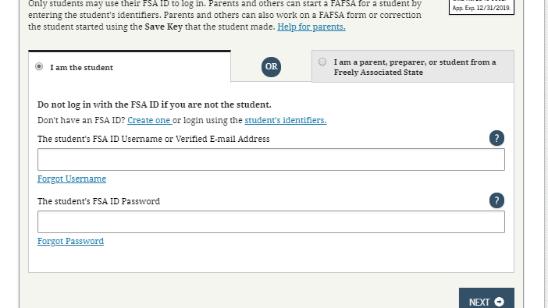

How do I apply for an FSAID?
Things you need to know:
- Create your FSAID at FSAID.ED GOV
- You cannot use the same email account as your parent when you create your ID.
2
- Be sure to use your correct name and social security number. This information will be verified with Social Security Administration.
- Record your FSAID information in a secure place. You will need it many times before you finish college.
- IMPORTANT: You will be asked to link your phone and email to the application. If you don’t want to link your phone there is a box you can uncheck just under the place where you enter your phone number. YOU MUST RECEIVE A CODE THROUGH YOUR EMAIL TO COMPLETE THIS PROCESS. This link can be used to retrieve your username and password if you lose it.
- You will be asked to choose four challenge questions. Try to choose questions that the answer never changes just in case you have to use them to retrieve your username and password.

3

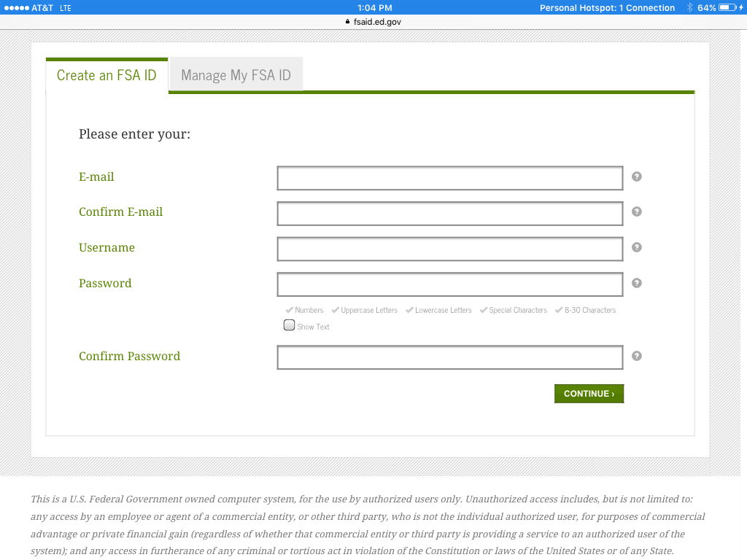

Whose income do I have to count?
If you live with: | Count income from:
Biological father and mother | Biological father and mother
Father and step-mother | Father and step-mother
Mother and step-father | Mother and step-father
Father | Father
Mother | Mother
Husband/Wife | Husband/Wife
If you can answer yes to any of the following questions, you are considered an independent student and only count your income:

- Do you have or will you have children who will receive more than half of their support from you between July 1, 2019 and June 30,2020?
- Are you currently serving on active duty in the U.S. Armed Forces or are you a veteran?
- At any time since you turned age 13, were both of your parents deceased, were you in foster care, or were you a dependent or ward of the court?
- As determined by a court in your state of legal residence, are you or were you an emancipated minor?
- Does someone other than your parent or step-parent have legal guardianship of you, as determined by a court in your state of legal residence?
- On or after July 1, 2018 were you homeless or were you self-supporting and at risk of being homeless?

4
PROVIDING PROOF OF INCOME
This is absolutely the most important step in applying for financial aid. If this process is not carefully addressed you can find yourself owing tuition to your school of choice. Please pay attention to these important points:
- You are applying for financial aid that is need based (based on income). You will need to verify you and your parent/s income. The simplest way to do this is to use the DRT (Data Retrieval Tool) that is available to you while you are completing your FAFSA. It will link to the IRS and transfer the information directly into your FAFSA.
- Sometimes the DRT does not work. You cannot use it if you are married filing separately or filed an amended return.
- It is important to remember that YOU MUST VERIFY YOUR INCOME. If you cannot use the DRT then you will need to obtain a tax transcript. You can request one online at https://www.irs.gov/individuals/get-transcript orcomplete the IRS form 4506-T and mail or fax to the IRS. The IRS will send you an official tax transcript that can be submitted to your school.
- Some students and parents are also required to verify that they DID NOT file a tax return. Proof of this can also be obtained by using the 4506-T and asking for a verification of non-filing. This will result in a letter from the IRS that verifies you did not file a tax return.

5

WHAT YOU WILL NEED TO COMPLETE YOUR FAFSA
Who Do You Live With?
Independent  Student | Live with  Both Parents | Live with  One parent | Live with Parent and Step-Parent
FSA ID for student | FSA ID for student and one Parent | FSA ID for student and parent you live with | FSA ID for student and parent or step-parent
Social Security # | Social Security # for  Both parents | Social Security # | Social Security #  (for parent and step-parent)
Birthdate | Birthdate for both parents | Birthdate | Birthdate  (for parent and step-parent)
Email Address  (for student and parent) | Email Address  (for student and one parent) | Email Address  (for student and parent you live with) | Email Address  (for student and parent)
Student Driver’s License Number | Student Driver’s License Number | Student Driver’s License Number | Student Driver’s  License Number
 | Date of marriage | Date of divorce or separation | Date of remarriage
2018 Tax return information for student | 2018 Tax return information for student and parents (just info from the front page) | 2018 Tax return information for student and parent you live with | 2018 Tax return information for student, parent and step-parent
Information regarding current cash/savings/checking | Information regarding current cash/savings/checking | Information regarding current cash/savings/checking | Information  regarding current cash/savings/checking
Investment values  (Stocks, bonds, etc.) | Investment values  (Stocks, bonds, etc.) | Investment values  (Stocks, bonds, etc.) | Investment values  (Stocks, bonds, etc.)
Business value | Business value | Business value | Business value
Farm and rental property value | Farm and rental property value | Farm and rental property value | Farm and rental  property value
Information regarding child support paid or received | Information regarding child  support paid or received | Information regarding child support paid or received | Information  regarding child  support paid or  received
Information regarding Workers’ compensation benefits | Information regarding Workers’ compensation  benefits | Information regarding Workers’ compensation benefits | Information  regarding Workers’ compensation  benefits
6

After you submit your FAFSA:
- Immediately-
Your will have a confirmation page as soon as you submit your FAFSA.
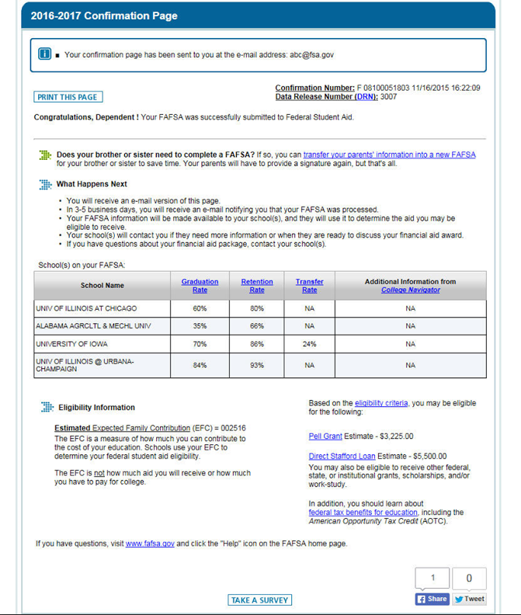
This section shows the schools that you have listed on your FAFSA. You can list up to 10 schools. List the one you are most likely to attend first.
$$$$

This shows what you are eligible
for in student loans. These are not free. This money must be repaid.

This is your PELL Grant award.
This is FREE federal money.
This can range from $0 to $6195,
depending on your income.

2020-2021 Confirmation Page

7
- 3-5 days after you complete your FAFSA, log into your account and print your
(SAR) Student Aid Report.
Your report may include some of the following:

. 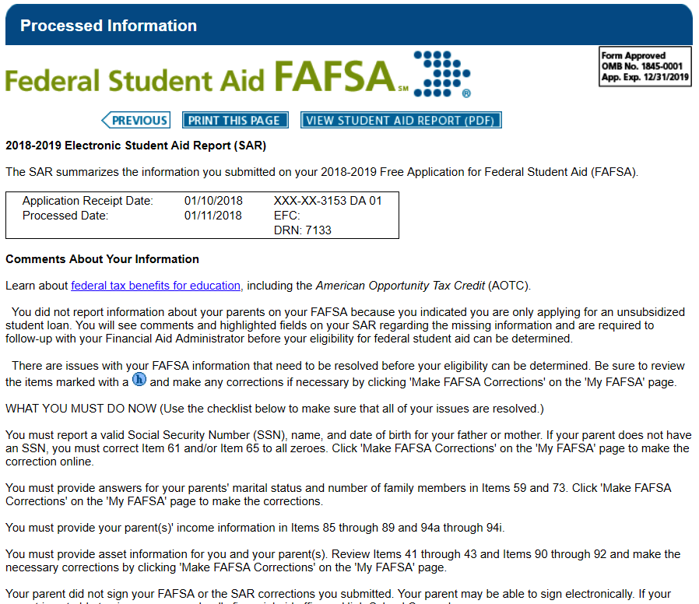

2019-2020
2019-2020

If your EFC is blank, there is an error in your FAFSA. The comments tell you what needs to be fixed. An * after your EFC means that you have been chosen for verification.
This symbol on your SAR shows you where the problem spots are.
8

What does it mean if I am chosen for verification?
IT
MEANS
EVERYTHING!
Once you apply to your school of choice you must stay in contact with financial aid at that school to make sure you have submitted everything they need for verification. If you do not….. none of your financial aid will post to your account.
We will have workshops this year that deal just with verification.
For Now-
Get your FAFSA completed!

9

Class of 2020 Claiborne High School
FAFSA Frenzy
Information

Appointment times will be provided to you at a later date. Our FAFSA Frenzy at CHS will be October 23 and 24, 2019.

