Agriculture Assignment
Tennessee Career and Technical Education Standards for Agriculture:
Large Animal Science - 4) Accurately maintain an activity recordkeeping system and apply proper accounting and financial records as they relate to a large animal science supervised agricultural experience (SAE) program or enterprise. Demonstrate the ability to summarize business records such as individual enterprise budgets, profit and lost statements, inventory management, transportation cost, and other specific reports by completing SAE and related financial applications.
Agricultural Power and Equipment and Ag Engineering - 5) Investigate opportunities to expand and diversify a Supervised Agricultural Experience (SAE) program as related to agriculture power and equipment. Accurately maintain an activity recordkeeping system and apply proper financial recordkeeping skills to summarize records by completing SAE related applications and reports.
Agriscience - 4) Determine how a Supervised Agricultural Experience (SAE) program functions as a method to apply concepts of the scientific investigation process (i.e. conducting an Agriscience Fair project). Compare and contrast the types of SAEs as related to their importance to the scientific investigation process.
I strongly believe in the 3 components of the Agricultural Education model. I feel at this time that the best way to address assignments and grades for my students is the continuation and development of your SAE's. This type of assignment encompasses the use of knowledge, experience and "hands-on learning" and applies to every type of class I teach; from Animal Science to Ag Mechanics. When assessing what type of assignment I wanted to do, I always came back to the model shown below (pg. 2).

With that being said; here is your assignment: Due date for all assignments is April 27, 2020
1. You are to continue with your SAE.
2. I ask that you continue to do a dated daily journal of your accomplishments, failures, or any other interesting bits of information related to your SAE.
3. I ask that you email me each Friday your Journal for the week. I also welcome pictures of you actively engaged in your SAE.
4. If you do anything new or different (ex; vaccinating a calf for the first time, or changing the oil in your lawn mower for the first time) that you make a special notation of that accomplishment.

*** For those who do not currently have an SAE:
- You are to research how to establish an SAE, maintain an SAE and the requirements for an effective SAE. *** After researching these guidelines, you are to write a 3 page essay detailing each component previously listed. These are to be emailed to me when completed.
- Establish an SAE. (This can be as simple as raising a tomato plant or flowers and properly maintaining them using correct methods).
- Keep records of your SAE; your accomplishments, failures surprises, etc.

In the event you do not have access to internet or a computer, you can turn your written paper journals on Apr 27. If you have any questions contact me via email and I will respond in a timely matter.

The FFA Motto states:
Learning To Do
Doing To Learn
Earning To Live
Living To Serve

This assignment certainly is reflective of the goals established by Agricultural Education and The National FFA Organization.
\
Again, I hope everyone stays safe and healthy,

Mike Wilmoth

Mission for Agricultural Education
Agricultural Education prepares students for successful careers and a lifetime of informed choices in the global agriculture, food, fiber and natural resource systems.

Foundation for Agricultural Education
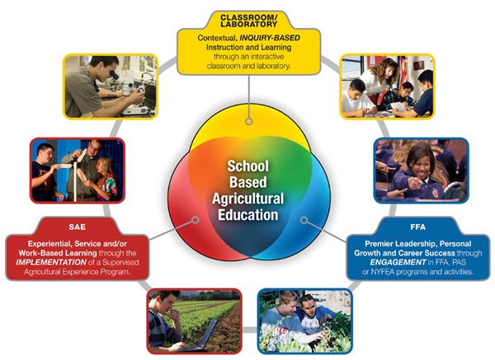
Classroom/Lab Instruction
Since 1917 with the passage of the Smith-Hughes Act, federal and state legislation has provided leadership for the implementation and improvement of agricultural education programs. The foundation of any successful Agricultural Education program is based on three inseparable, equal, and interdependent components that include: rigorous Classroom Instruction, FFA leadership and relationship development activities, and Supervised Agricultural Experience projects that provide relevant skills in agriculture.

Supervised Agricultural Experience
An agricultural education program is made up of three integrated parts: Classroom Instruction, FFA and Supervised Agricultural Experience (SAE). Students with an SAE learn by doing. With help from their agricultural teachers, students develop an SAE project based on one or more SAE categories.

