Campus Map

B O
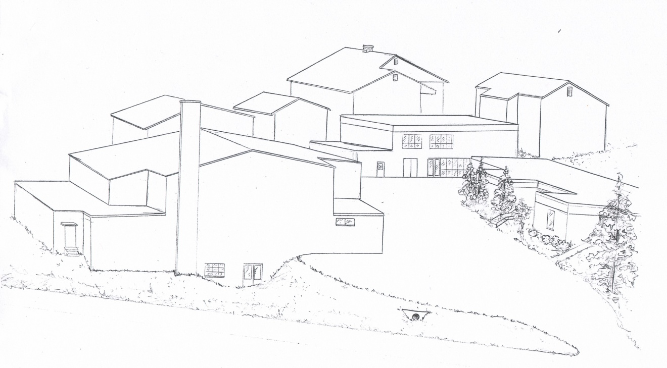
F C A
E D M
Q G K L J P
H I
Parking N

Loading/Unloading students
WELCOME to Forge Ridge School

Entrance

Legend

A Kindergarten J Computer Room
B 1st – 2nd Grade K Kitchen
C Nurse/Speech L Dining Room
D Storage M Principal’s Office
E Maintenance N Dragon Pantry/Alpha Pre-K
F 7th & 8th/Intervention O Playground
G Gym P Library
H 5th – 6th Grade Q Greenhouse
I 3rd – 4th Grade

ALL VISITORS MUST REPORT TO THE PRINCIPAL’S OFFICE UPON ARRIVAL. NO EXCEPTIONS!

Forge Ridge School campus has a Safety Resource Officer/ Claiborne County Deputy available at ALL times during school hours

