I ____________________________ have read the LEAPs Parent/Student Handbook.
Parent Name
I have a clear understanding of what is expected of my child and of me while he/she attends the LEAPs Program. I agree to explain the orientation packet to my child so that he/she will understand what is expected of them.

I ____________________________ have read the LEAPs Parent/Student Handbook and/or
Student Name
I have had the information in this booklet explained to me by my parent/guardian. I have a clear understanding of what is expected of me while I attend the LEAPs program.

__________________________________________ _________________
Parent/Guardian Signature Date

__________________________________________ _________________
Student Signature Date

* I have been shown/offered the DOE Child Care Rules and Guidelines ________________________
Parent Signature/Date
Child Abuse Reporting
Call the Child Abuse Hotline if you suspect a child is being abused or neglected.
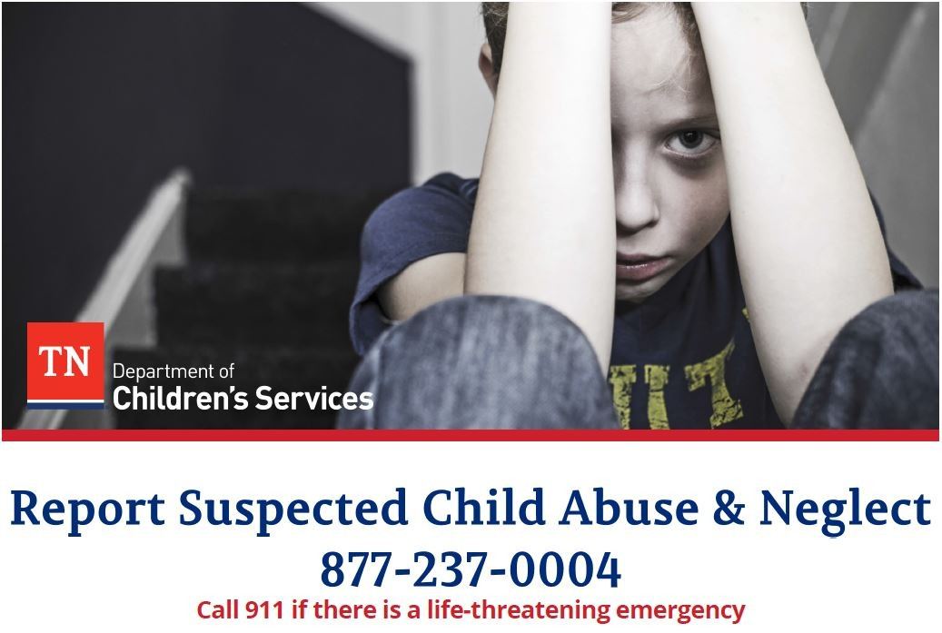
Call the Child Abuse Hotline to report child abuse or neglect in the State of Tennessee.

1-877-237-0004
Call 911 if there is a life-threatening emergency
Reports also can be made online on our secure site in a non-emergency situation
https://apps.tn.gov/carat/
- Our trained case managers will guide Hotline callers through a series of questions.
- Callers do not have to know all the details of the abuse or neglect.
- The Hotline case managers use the information you provide to determine the severity of the situation and how best to intervene.
- Learn More: Visit the DCS website at tn.gov/dcs to learn more about keeping children safe

Midway Elementary School
LEAPs After School Program 2022/2023

Student Name: ______________________________Grade ________
Parent/Guardian Name: _____________________________ Relationship_____________
Mailing Address ____________________________________________________________
Home Phone: _____________________ Mobile/Cell Phone: _________________________

Place of Employment: ______________________________ Work Phone: ______________

→In case of an Emergency, please list 2 other ADULTS, other than primary Parent/Guardian

1. Name: _________________________________Relationship:______________________

Home Phone: ___________________________ Cell Phone: _______________________

Place of Employment________________________________ Work Phone _______________

2. Name: _________________________________ Relationship:_______________________

Home Phone: __________________________ Cell Phone: _________________________

Place of Employment________________________________ Work Phone _______________

→I wish to enroll my child in the Midway Elementary After-School Program. By signing this form, I acknowledge that this program is offered before and after school hours and regular school guidelines and rules apply.
Parent Signature:___________________________________________

Does the student have any known allergies? Yes or No
If so, please describe: ___________________________________________________________________________

Transportation Plan:
All students must be picked up by 5:30 no exceptions.

Person responsible for picking up student___________________________________________________

Contact number:__________________________ Alternate Number: _____________________

Person responsible for picking up student___________________________________________________

Contact number:__________________________ Alternate Number: _____________________

Emergency Consent to Treat
In case of an emergency, I/we give permission for authorized personnel to have my child transported to the hospital by EMS if the parent/guardian cannot be reached. In such cases:

Physician’s Name: _______________________________ Phone # _____________________
Medical Insurance: ____YES ____No

Current Medications:__________________________________________________________

Parent Signature: _________________________________________

